1. **Home Page**

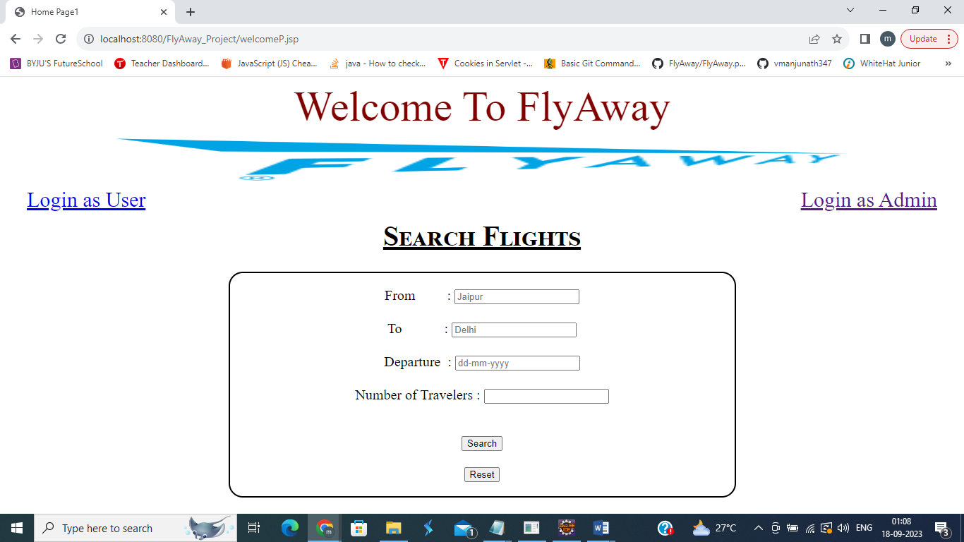

* 1. **Search Flights – Flight Details Entered with any of the field empty -> Message will be displayed that no Flights Available**

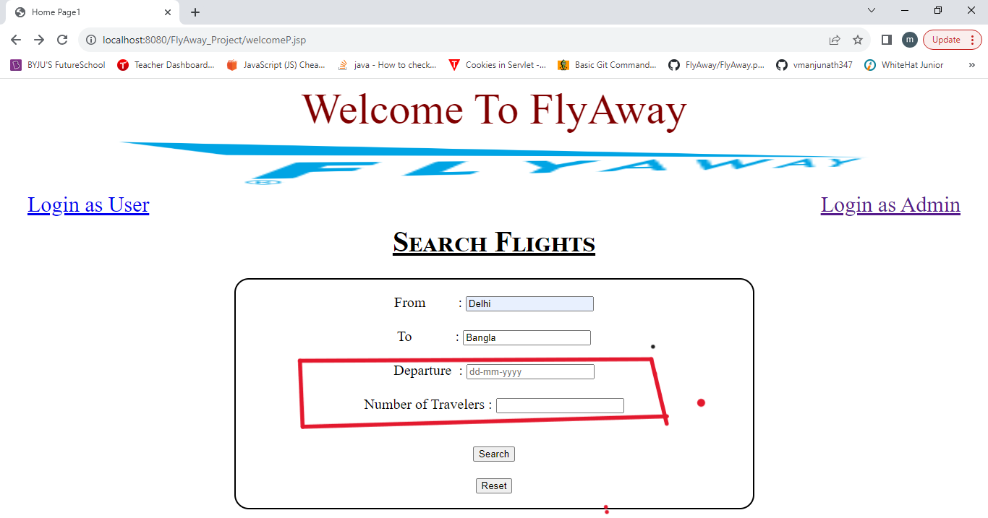

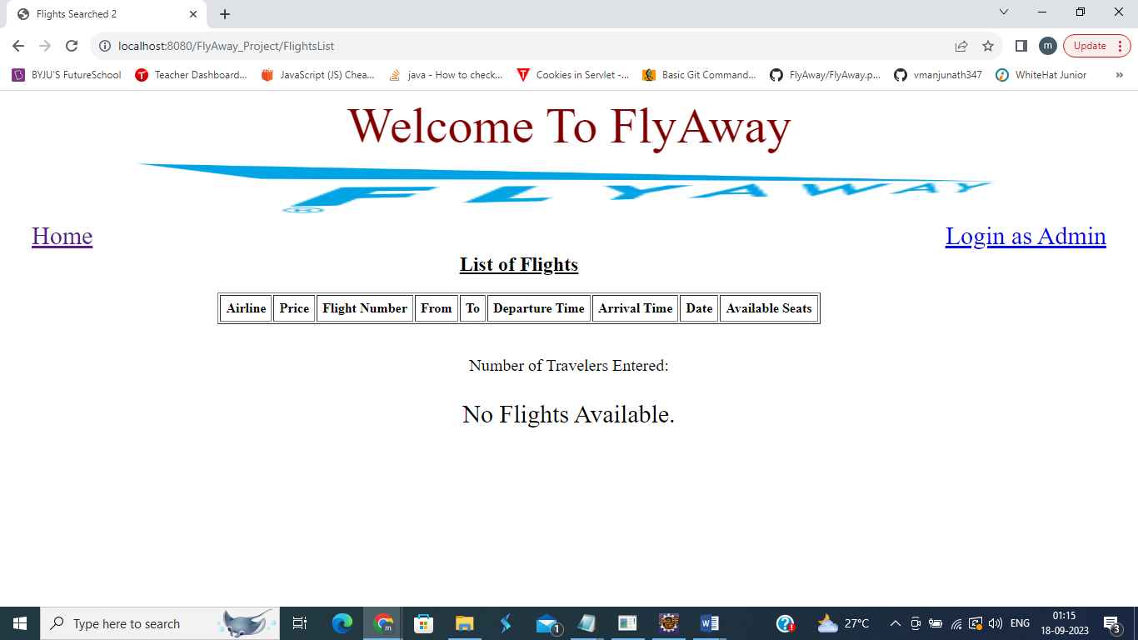

* 1. **Search Flights – When Correct Flight Details Entered, flight list will be displayed**

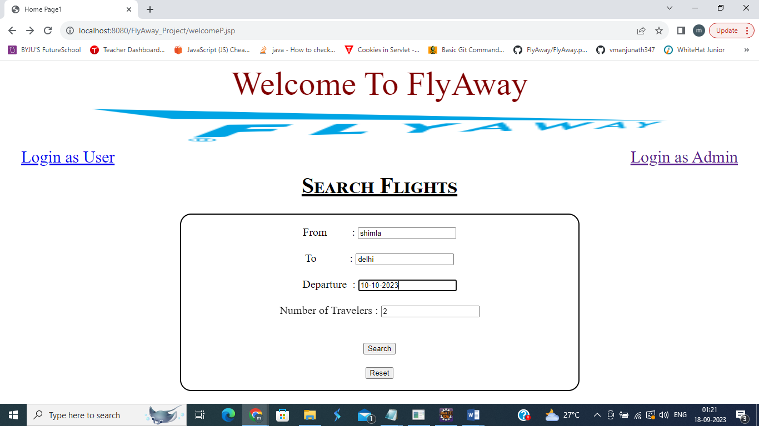

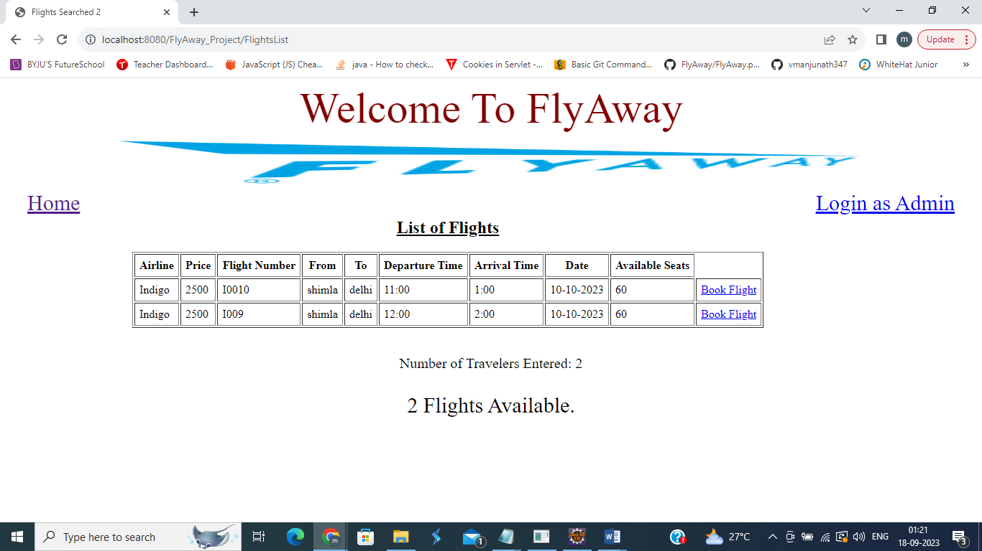

1. **Click on Book Flight against flight to book – User Login Page Opens (as not logged in)**

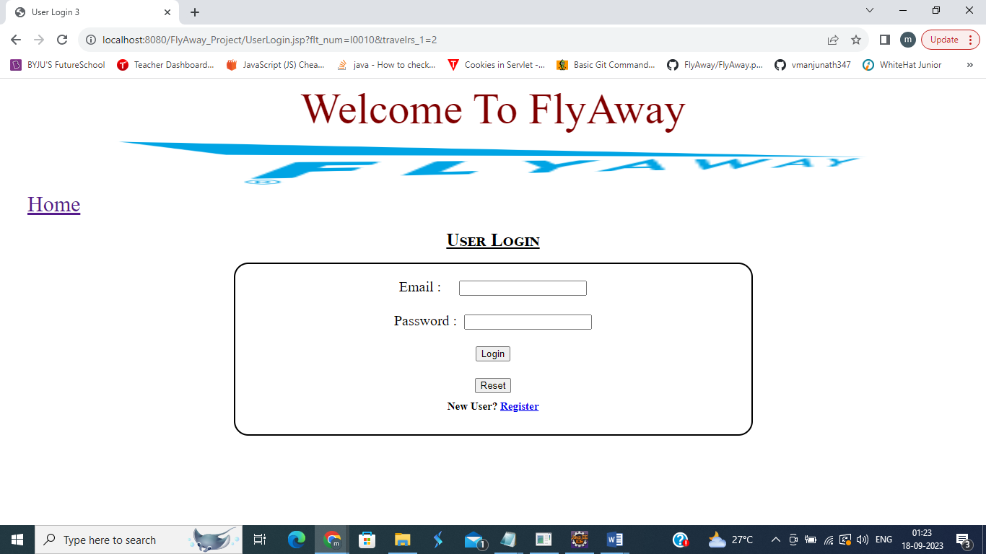

1. **For Existing User**
   1. **Incorrect Details/ No details Entered and Login Clicked – Error Message Displayed**

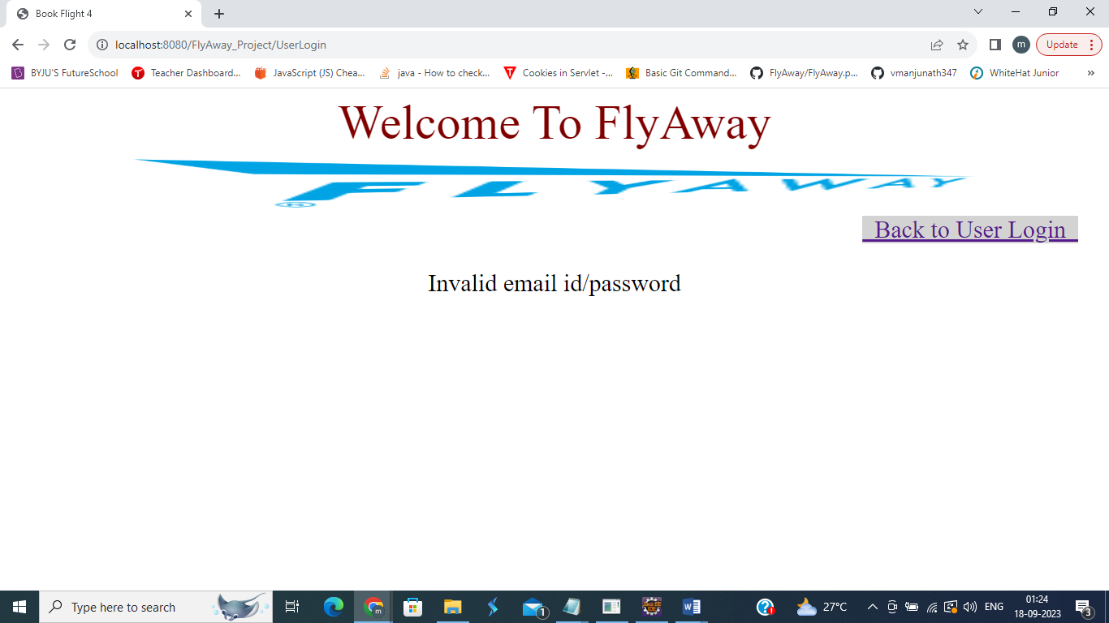

* 1. **Correct Details Entered – User and flight details displayed**

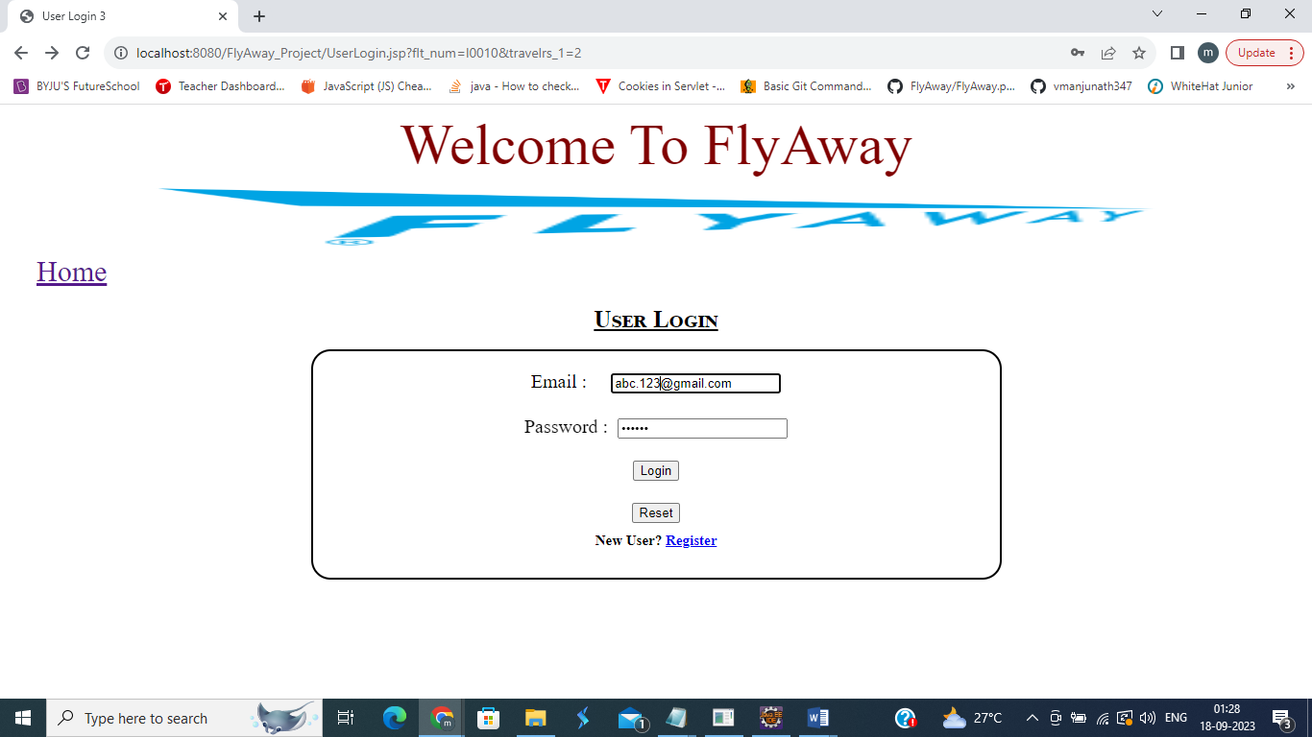

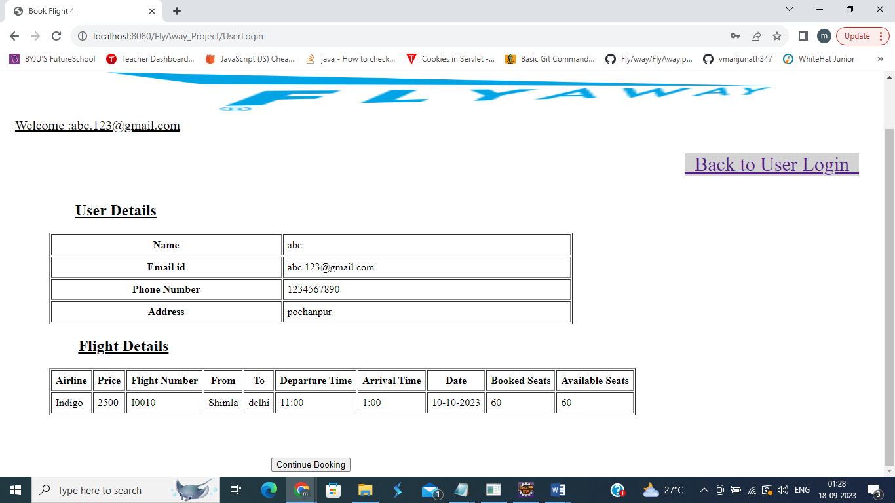

* 1. **Continue Booking Button Clicked – will navigate to Dummy Payment Page**

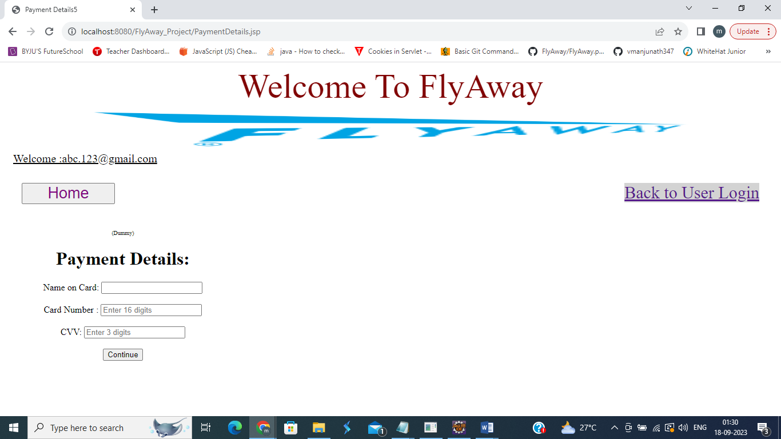

* 1. **If any field empty on Payment Page – Error Message is displayed**

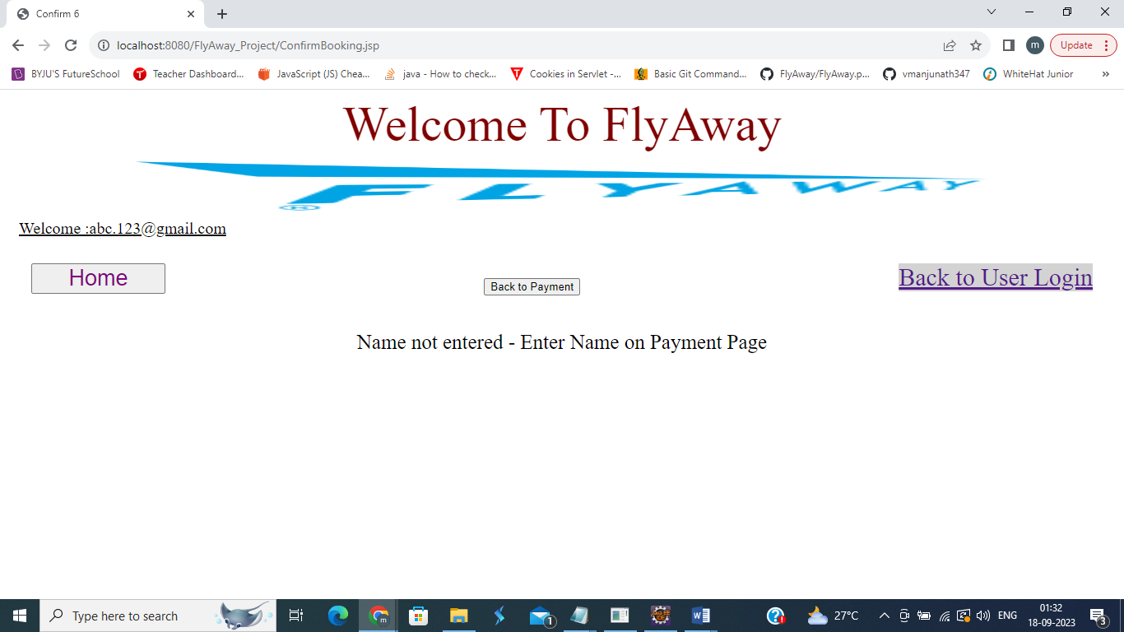

* 1. **Details Entered on Payment Page – Continue Button will navigate to Confirm Booking Page**

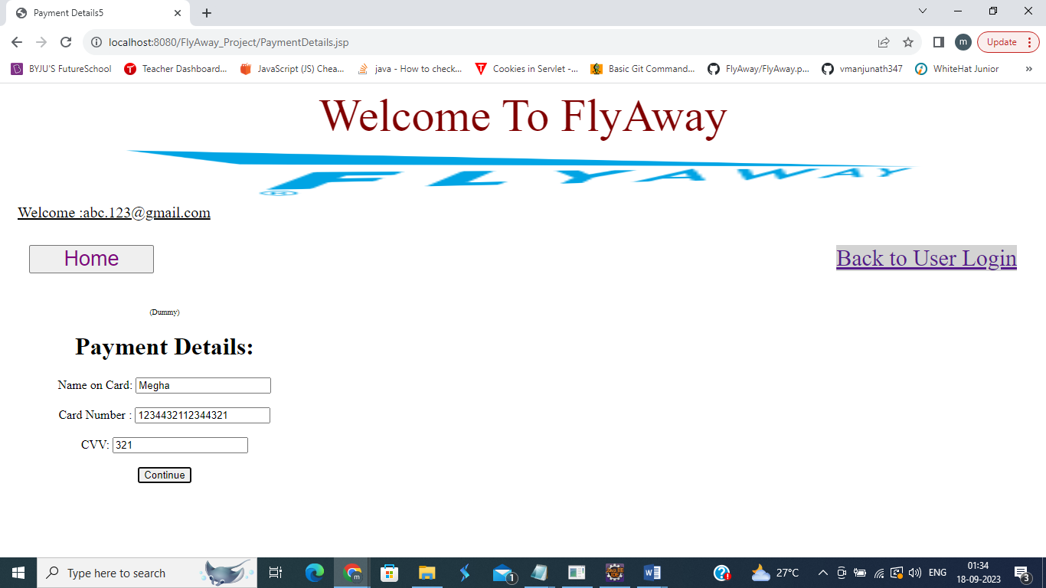

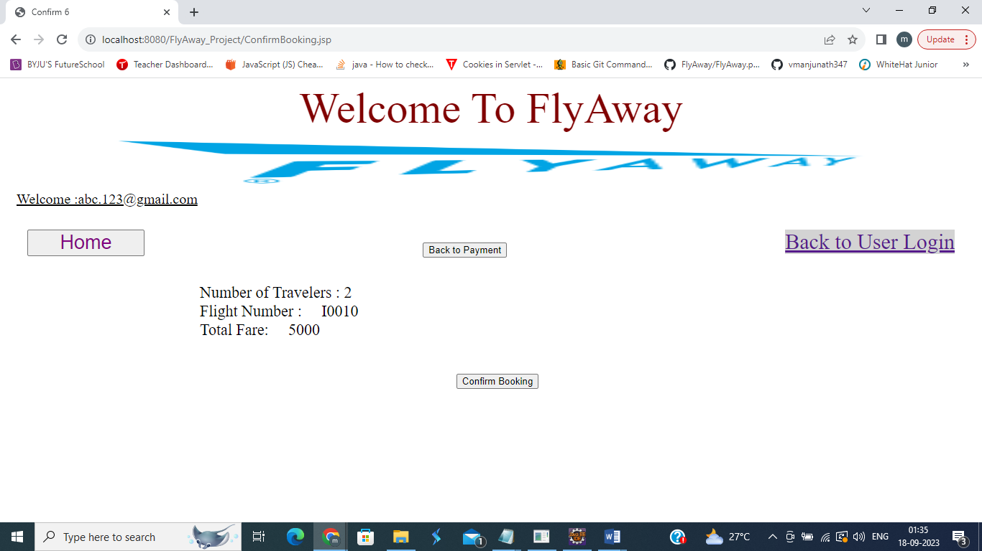

* 1. **Clicking on Confirm Booking Button**

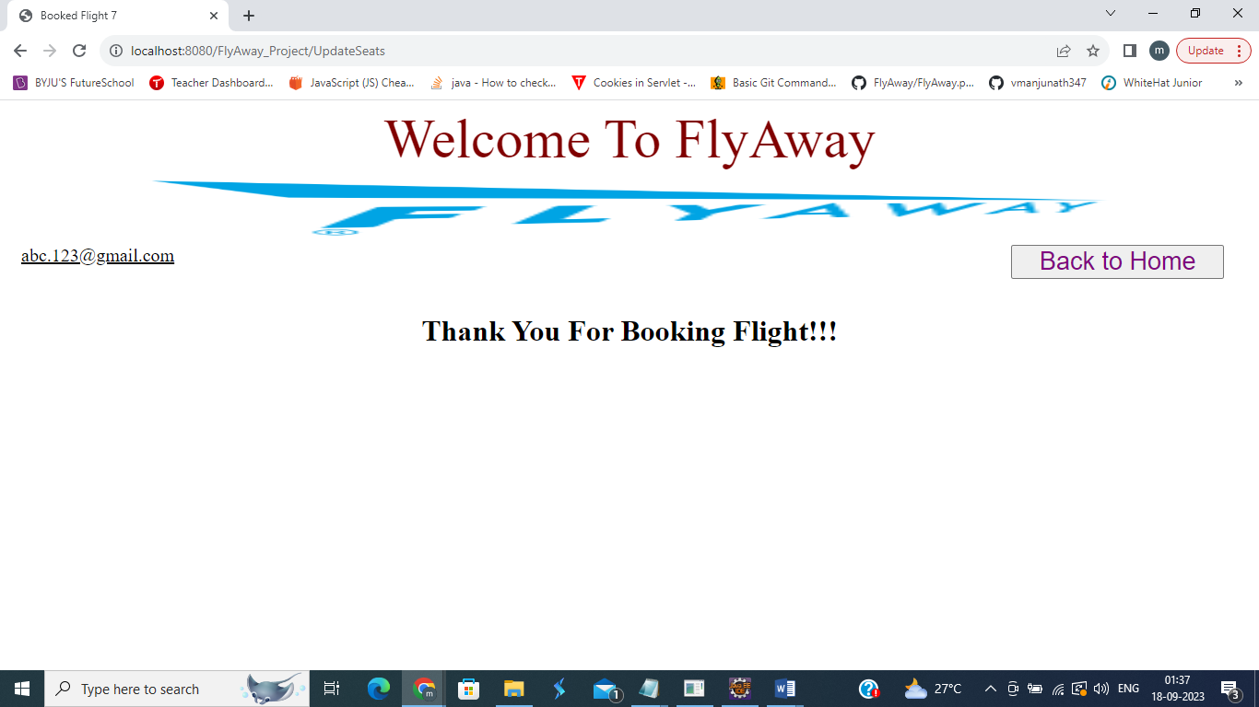

1. **For New User**
   1. **Click on Register**

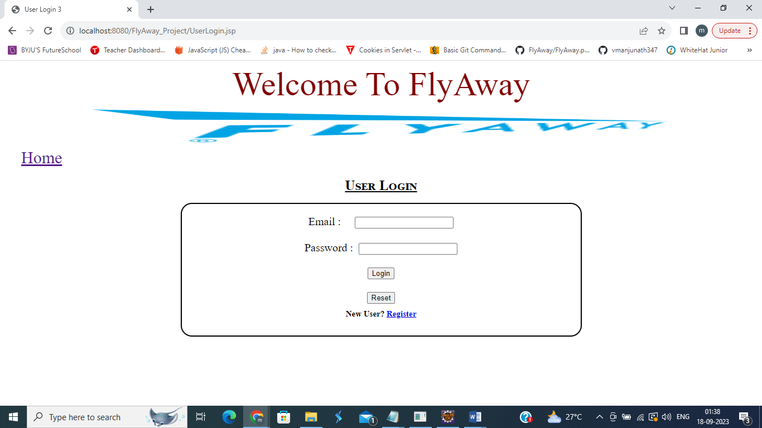

* 1. **Input User Details Page will open**

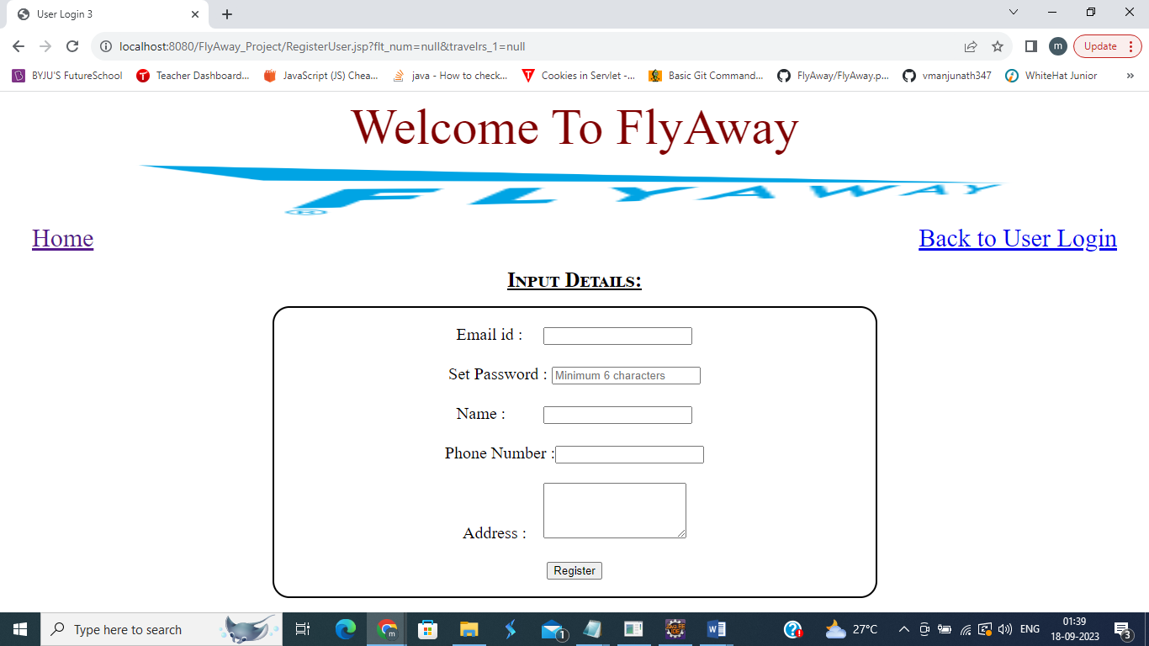

* 1. **If any field is empty – error message is displayed**

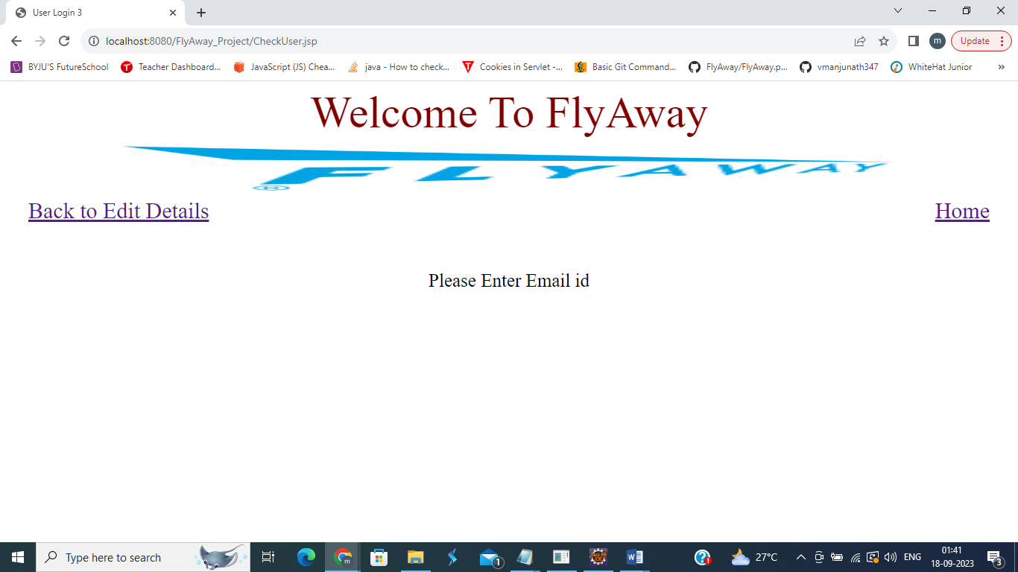

* 1. **If already registered email id is entered – error message is displayed after confirming details**

**Confirming Details**

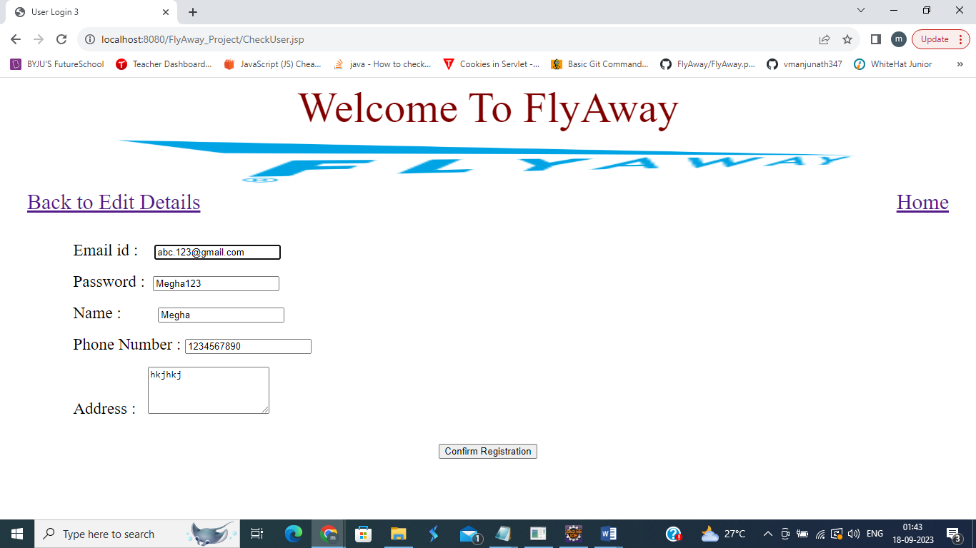

**Error Message**

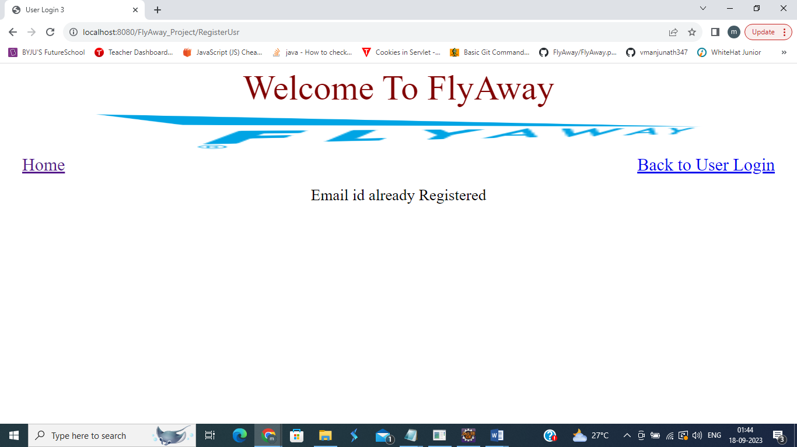

* 1. **Registering New User – Enter Details**

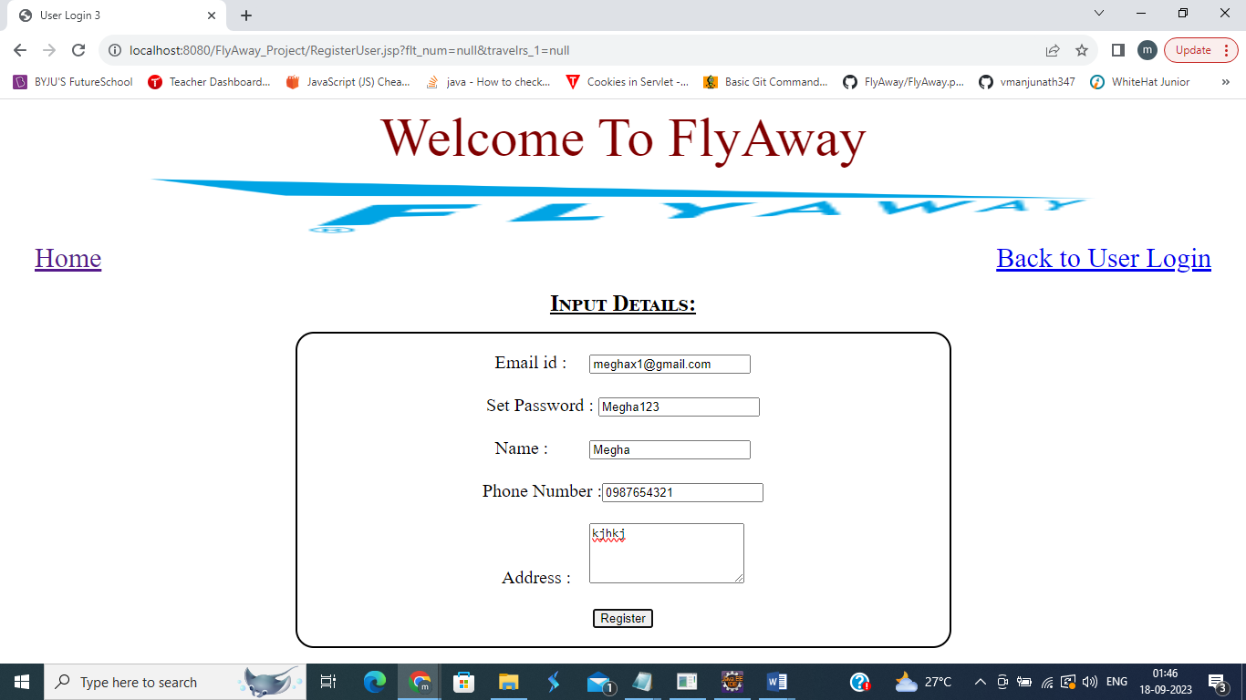

**Confirmation Page**

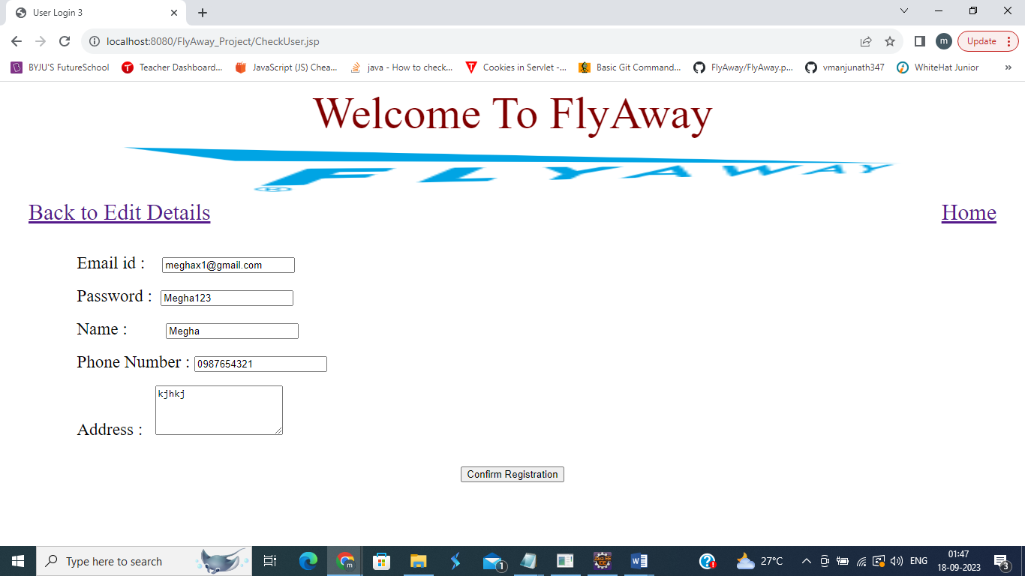

**User Registered Successfully**

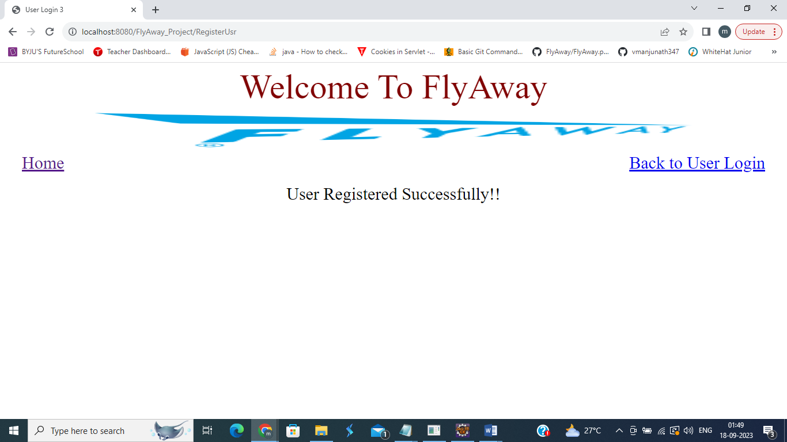

1. **Home Page – Clicking on “Login as User’**

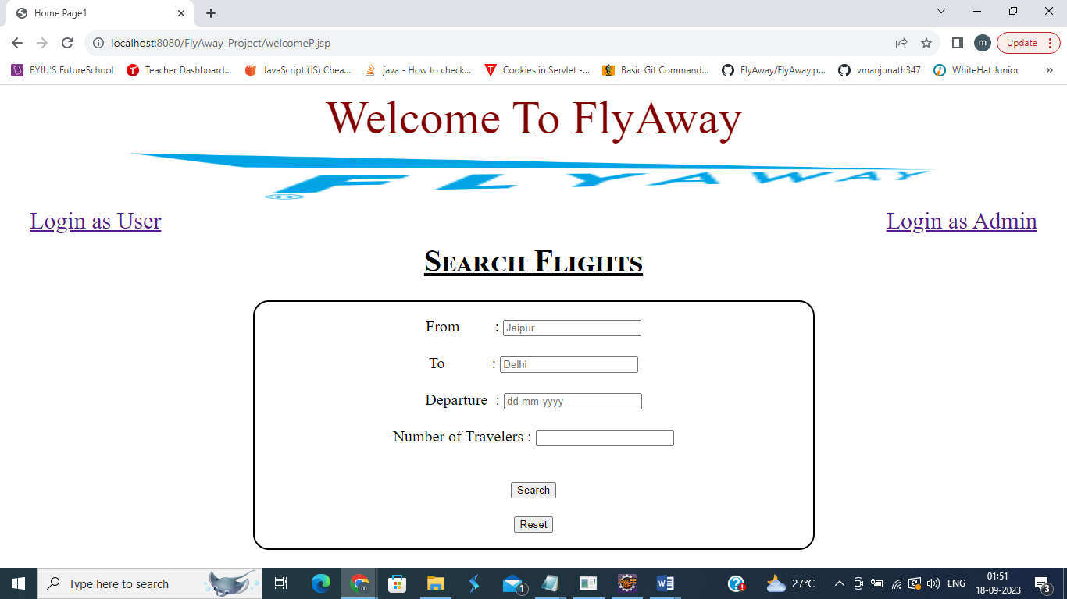

* 1. **User Login Page**

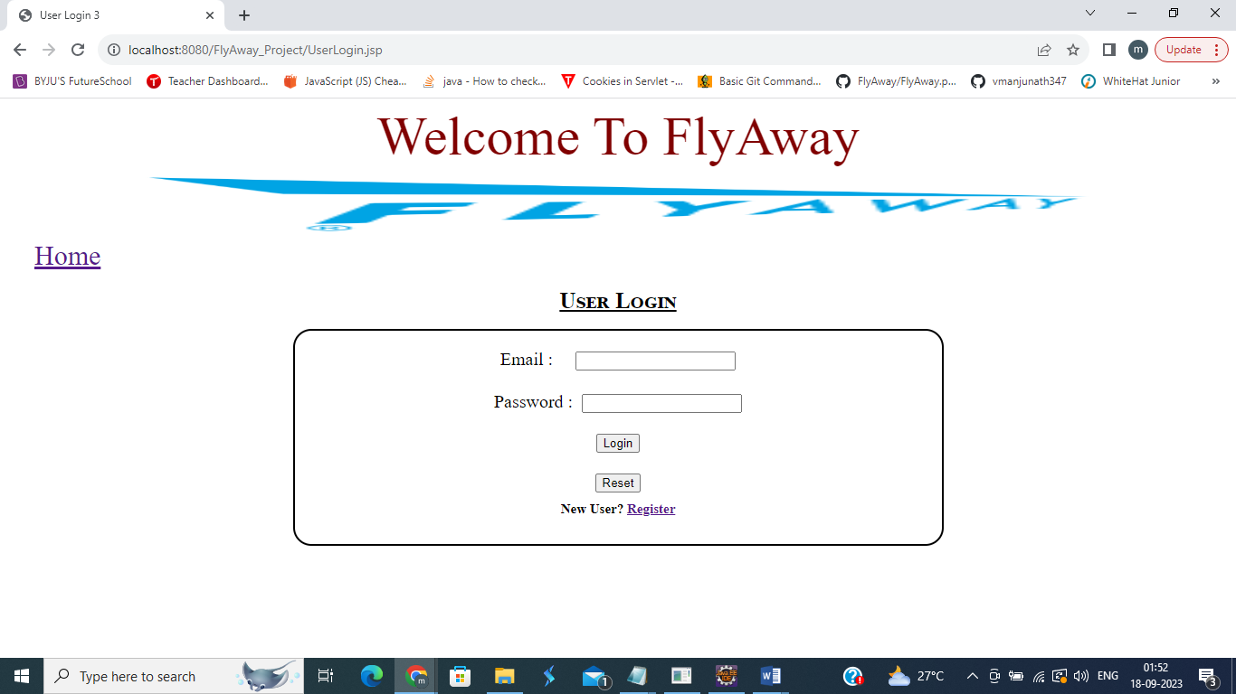

* 1. **Correct details Entered – Will display user details and ‘Search Flight’ Button.**

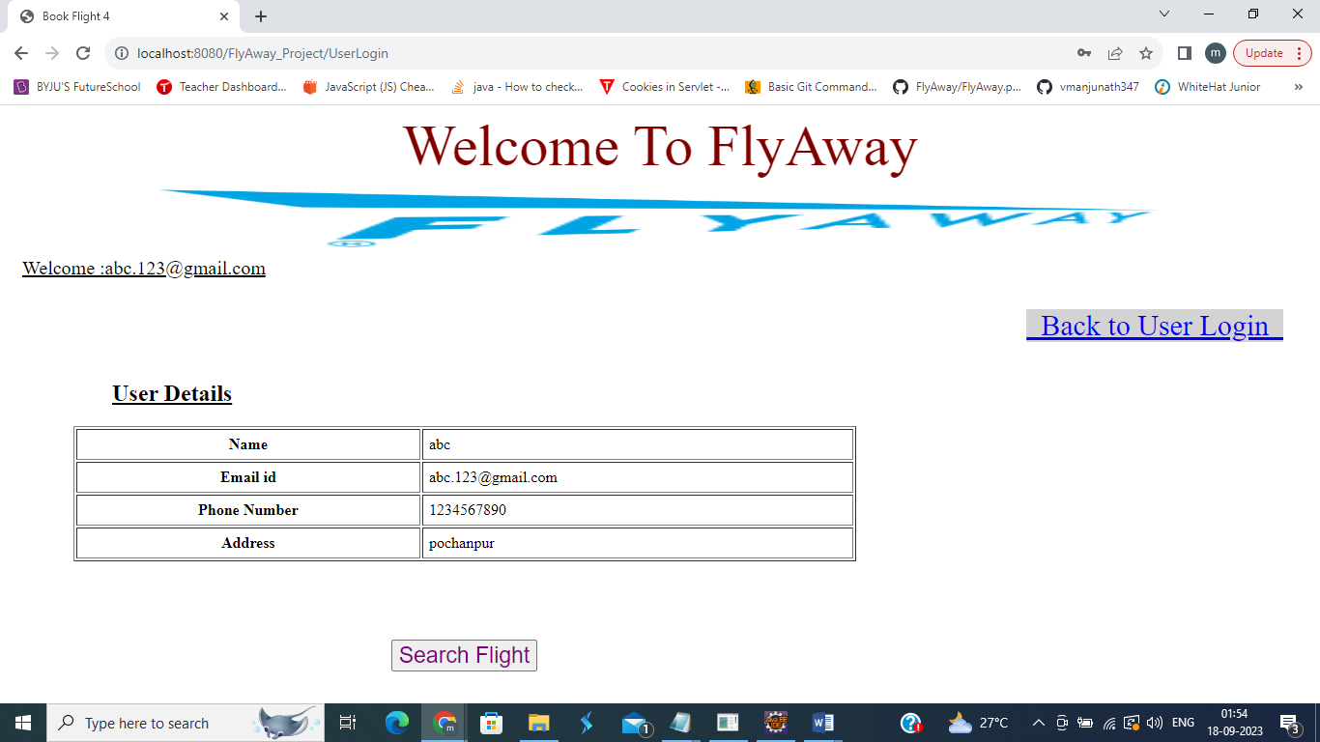

* 1. **Clicking on Search Flight will take to home Page with User login id and logout. To book flight will not have to login again.**

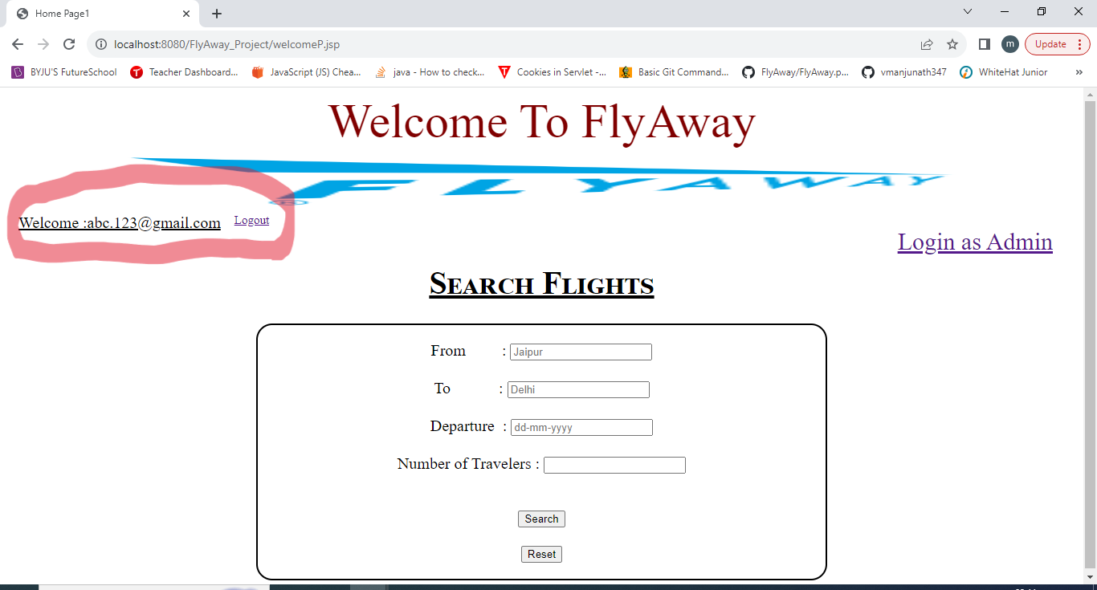

**Incorrect details entered in 6.1 will display errors as shown in 4.1.**

**Register Clicked on 6.1 will display as in 5.1.**

1. **Home Page – Clicking on “Login as Admin”**



* 1. **Admin Login Page**

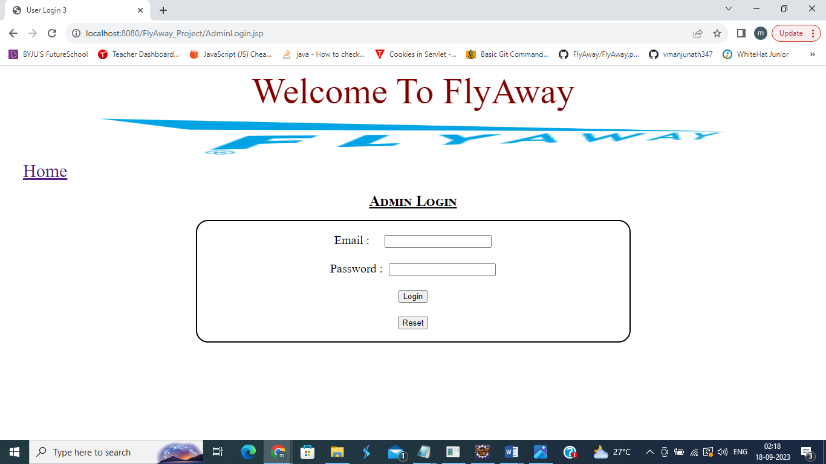

* 1. **Blank Fields and clicking on Login will display error message**

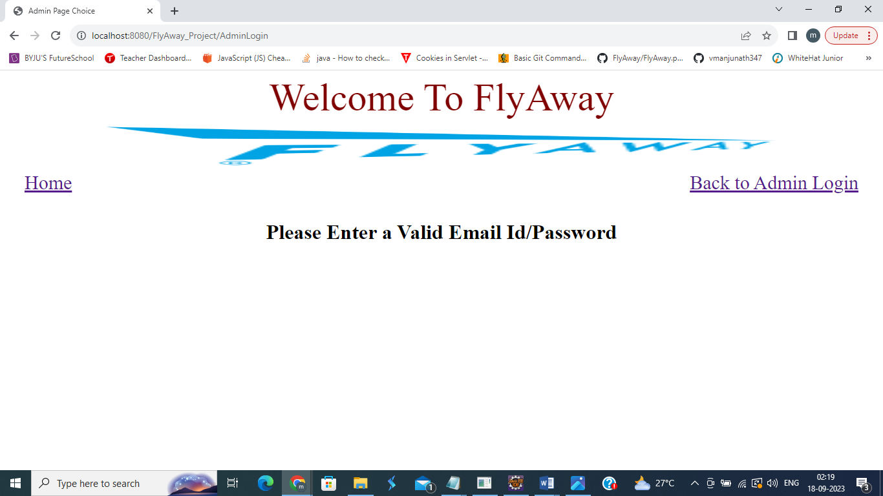

* 1. **Incorrect Admin id and password**

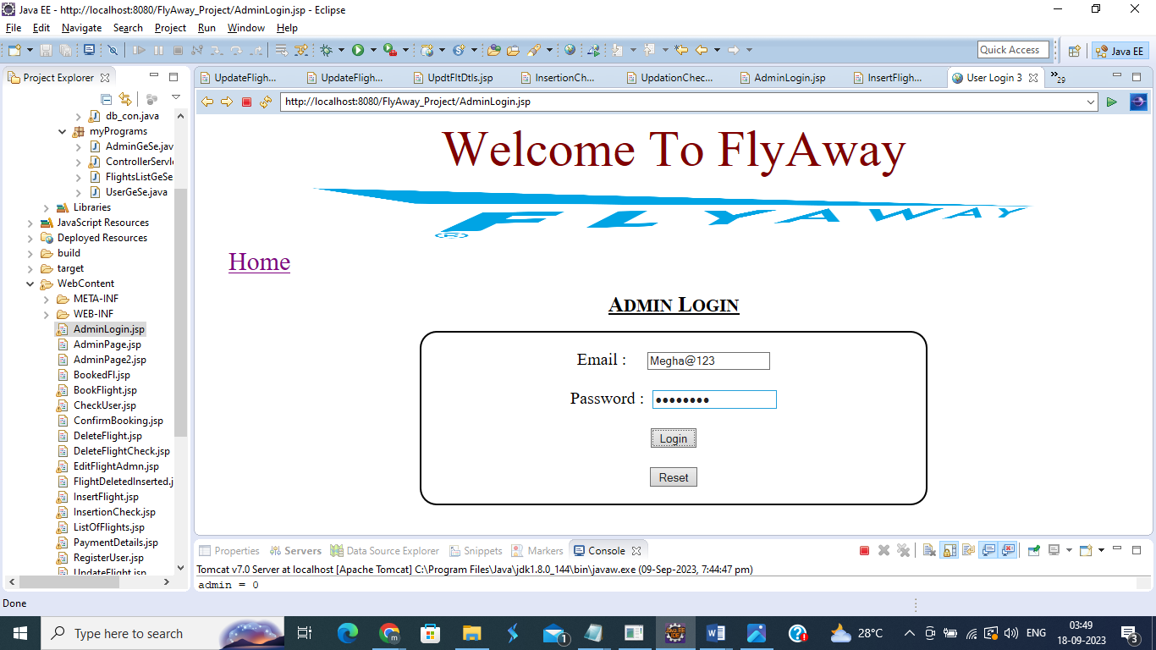

**Error Message Displayed**

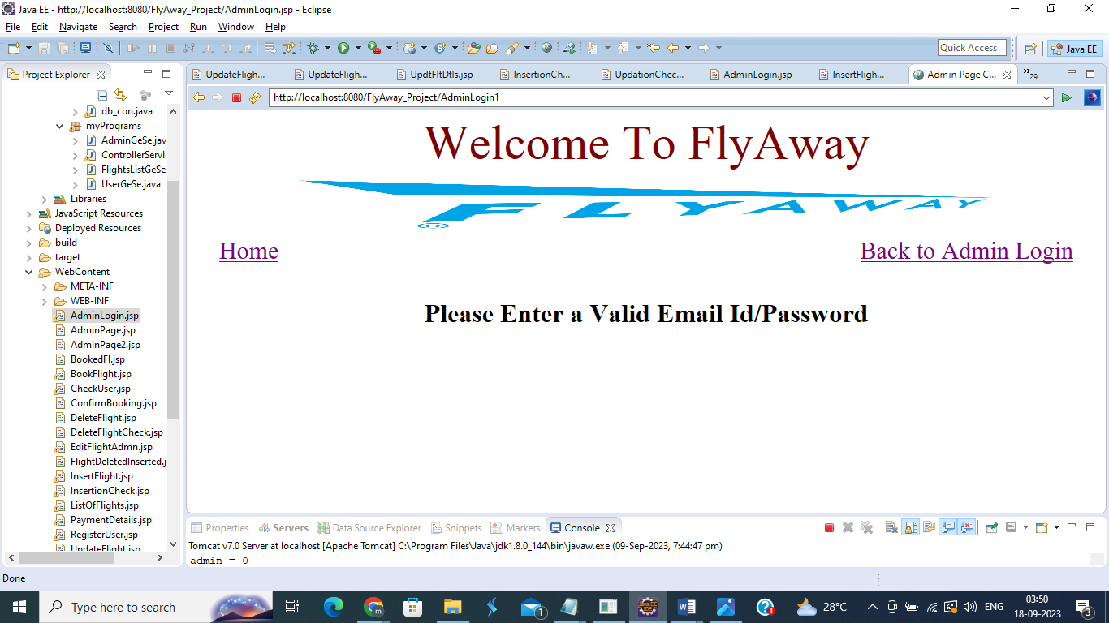

* 1. **Entering correct Admin id and password – will navigate to Administrator Page**

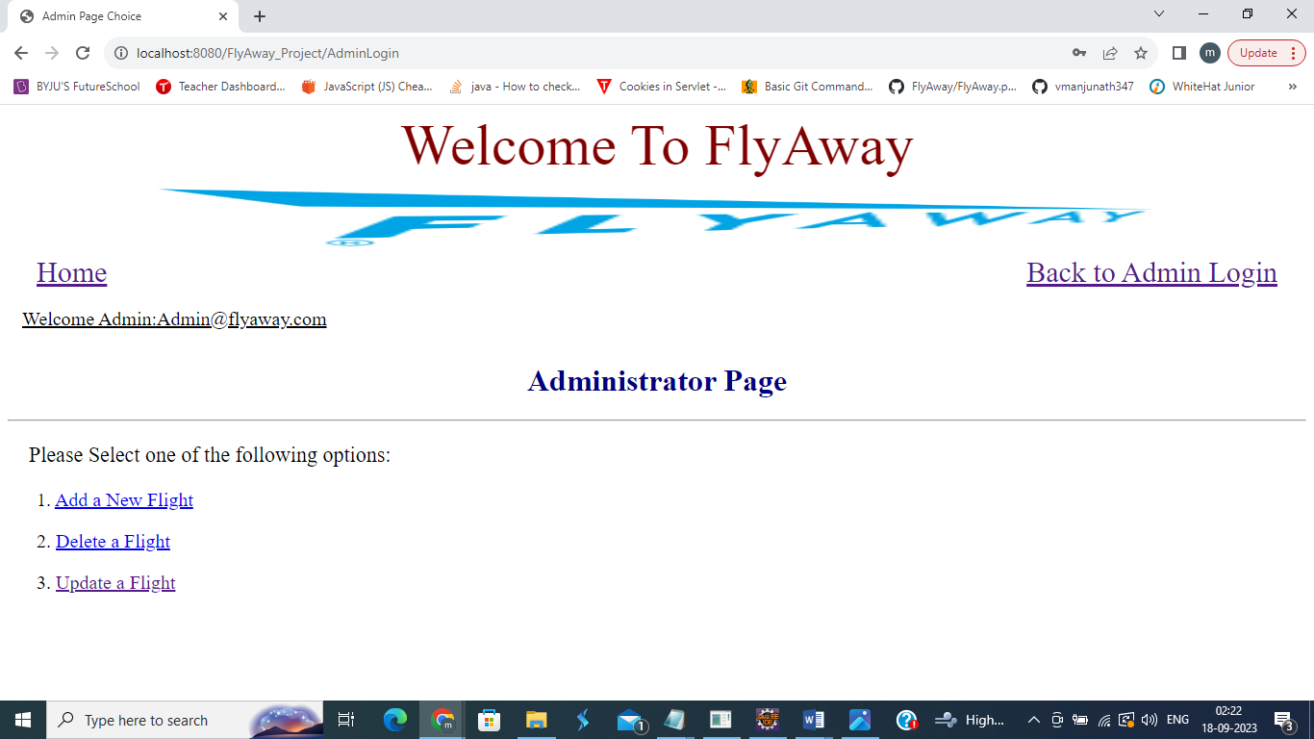

* 1. **Add New Flight**
     1. **Enter Flight Details**

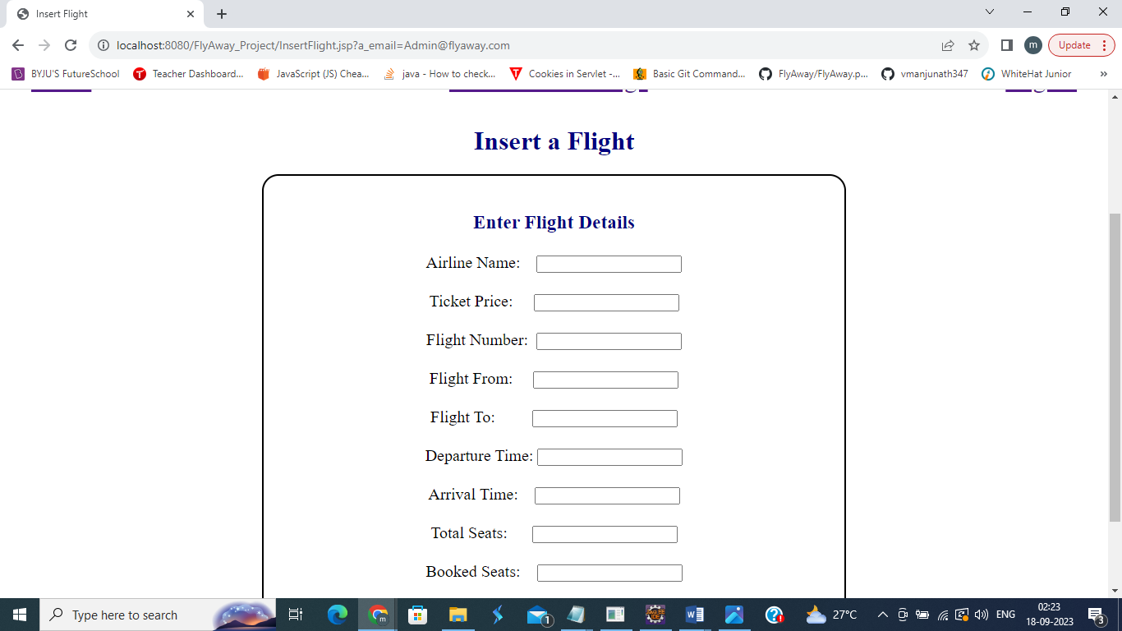

* + 1. **If any field is empty – error message is displayed**

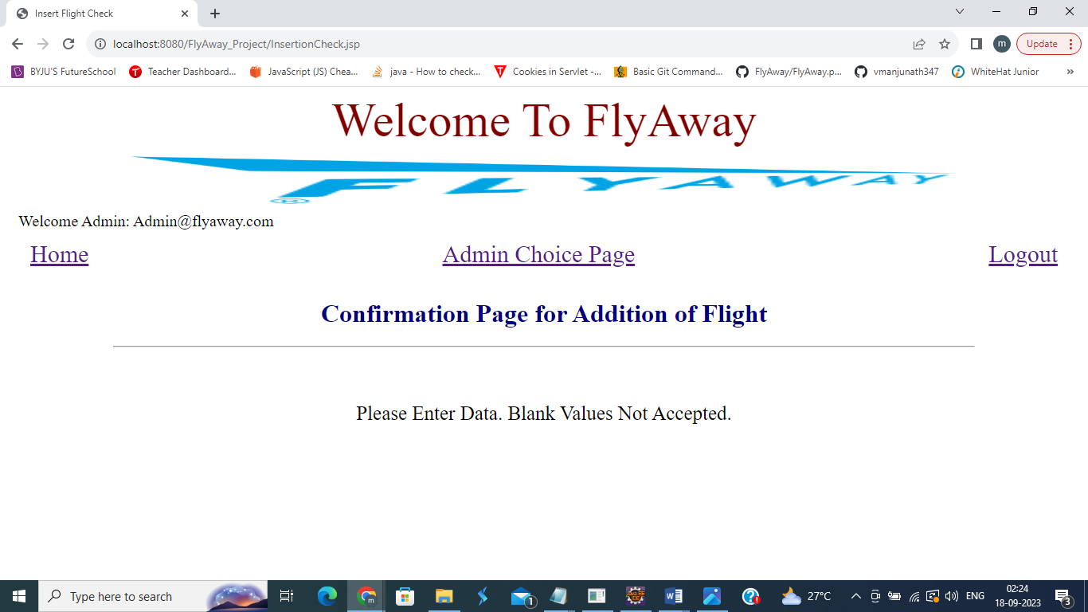

* + 1. **If Already Existing flight number is entered to be added, error message is displayed**

**Confirmation Page**

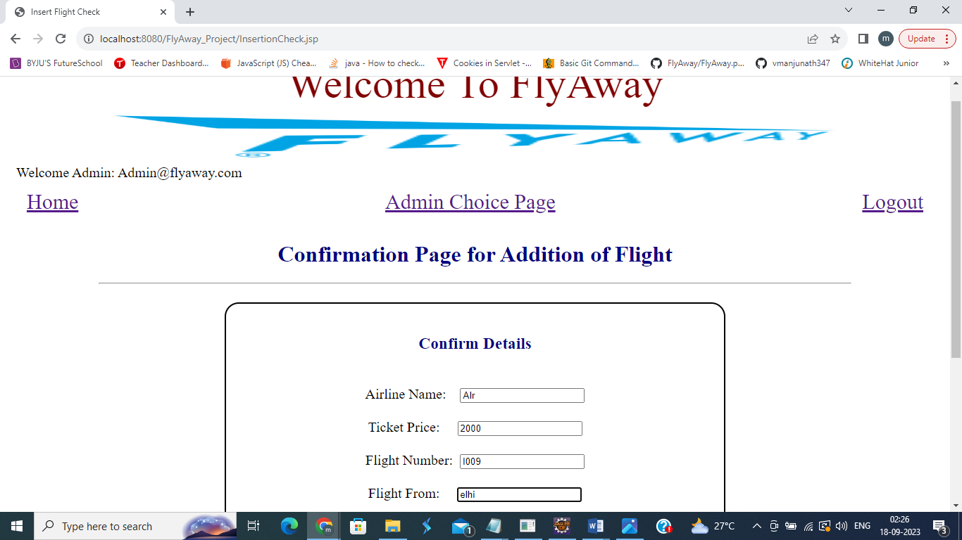

**Error**

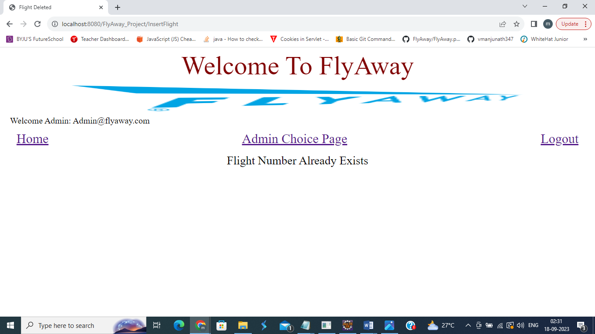

* + 1. **If new Flight Number details are entered**

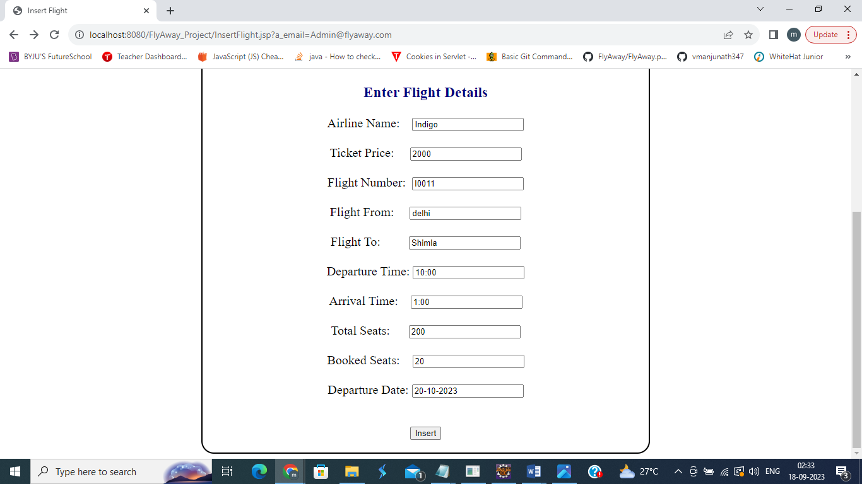

**Confirmation Page**

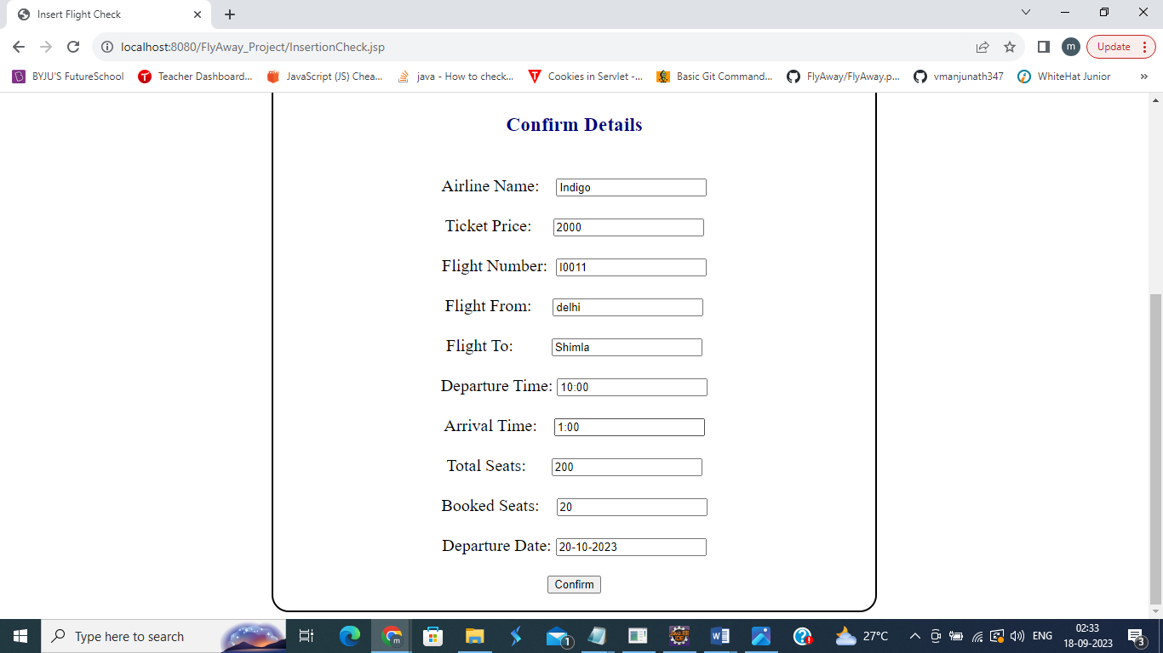

**Flight Inserted**

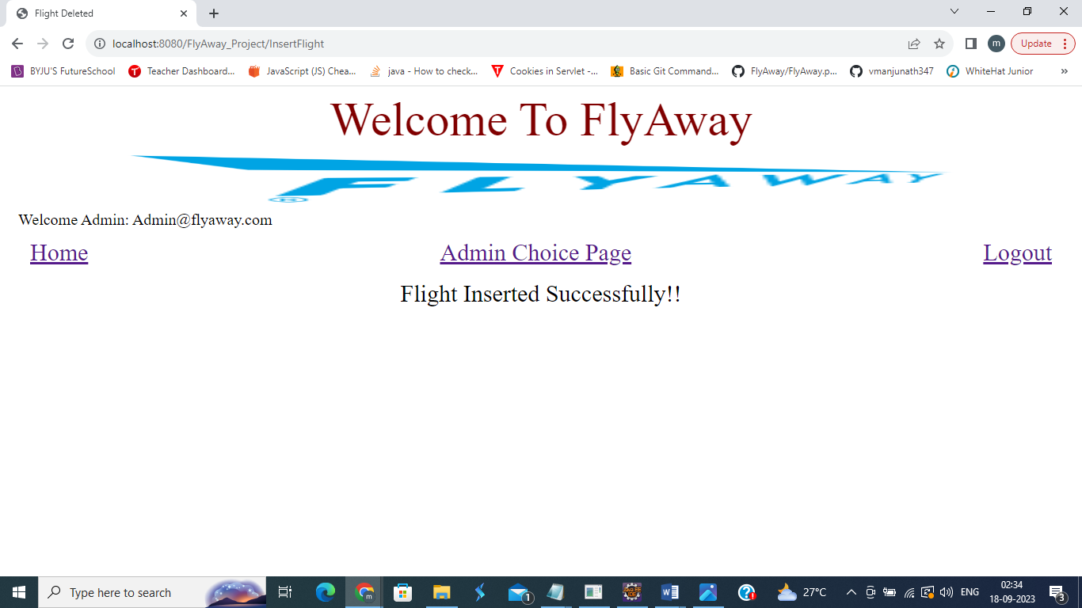

* 1. **Delete Flight**
     1. **Enter Flight Number**

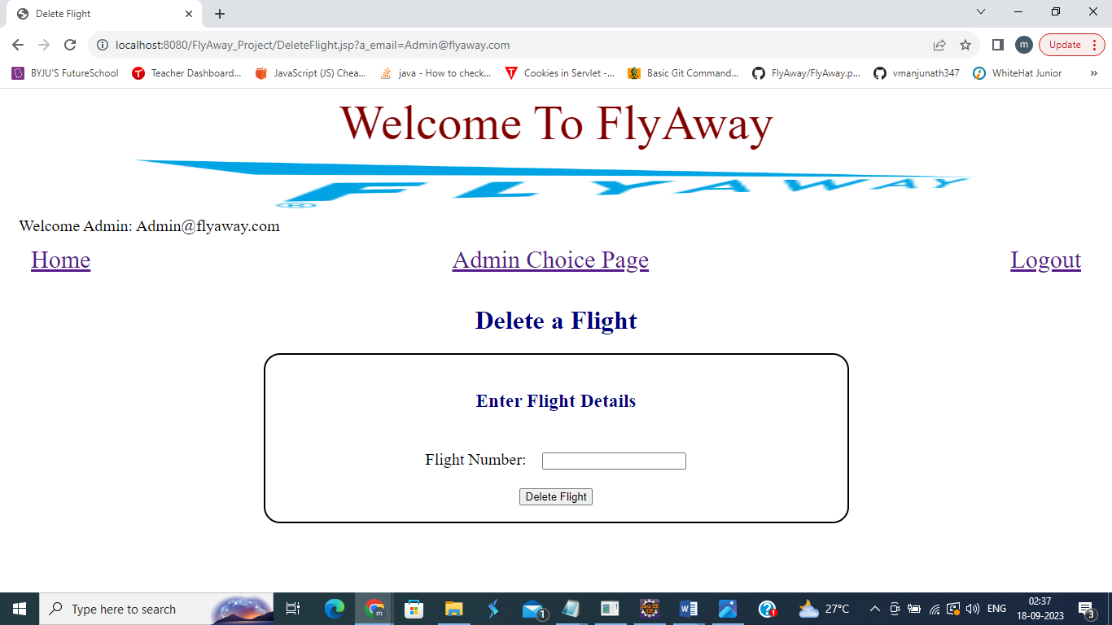

* + 1. **Empty Flight Number, will display an error**

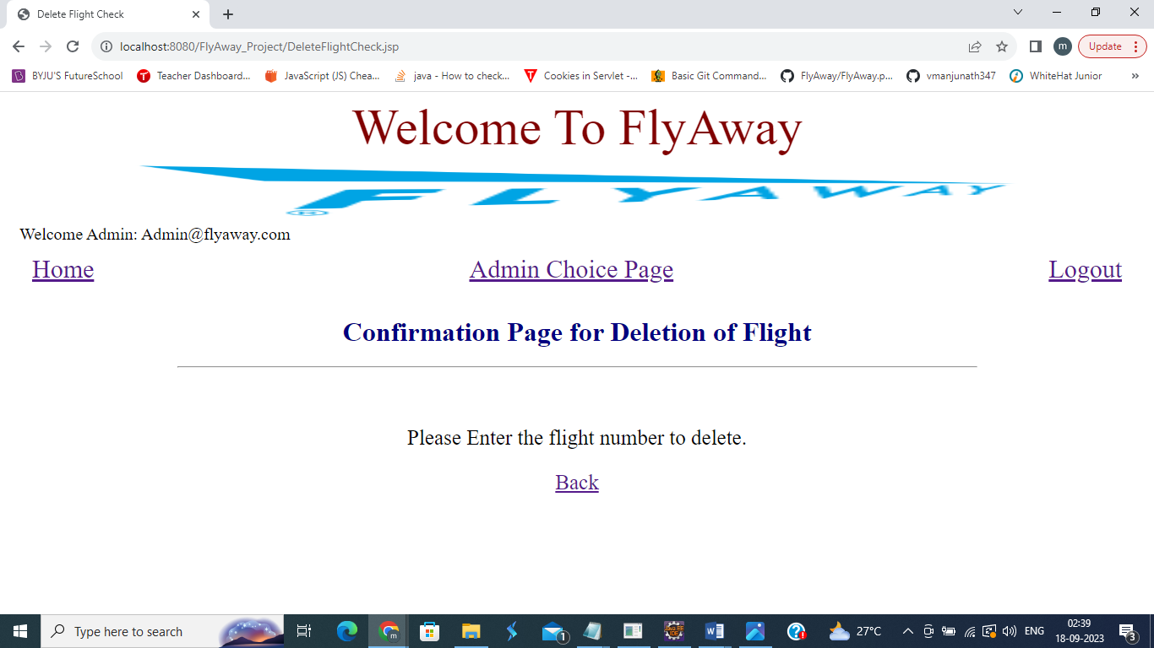

* + 1. **Flight Number Entered that does not exist in DB, will display an error**

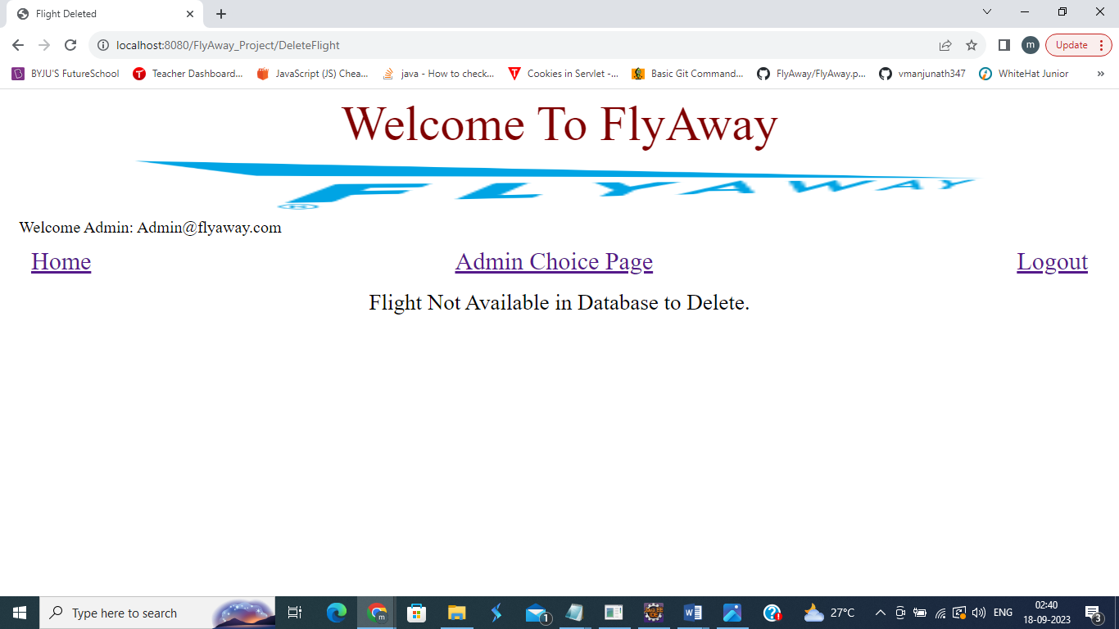

* + 1. **Correct Flight Number Entered to delete**

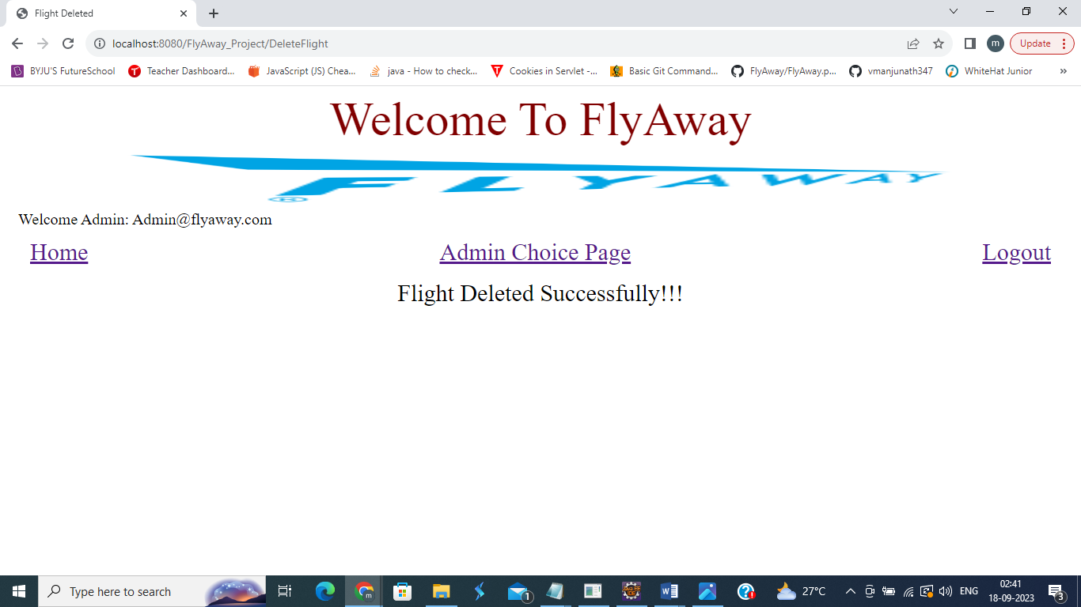

* 1. **Update a Flight**
     1. **Enter Flight Number**

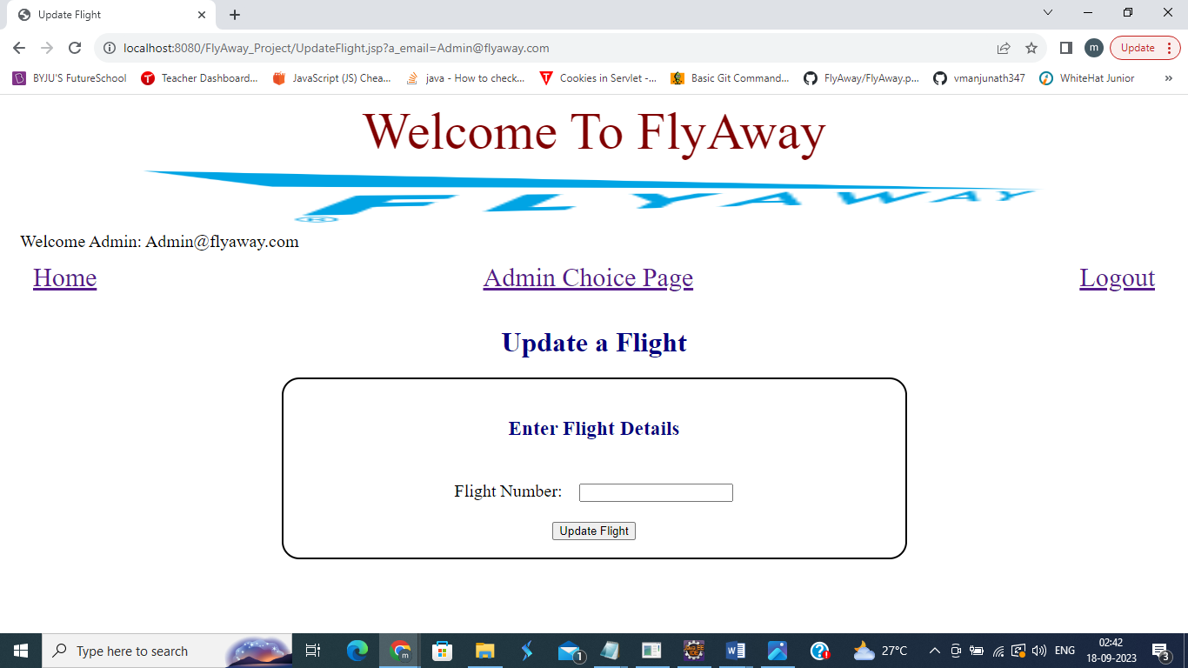

* + 1. **Empty Flight Number, will display an error**

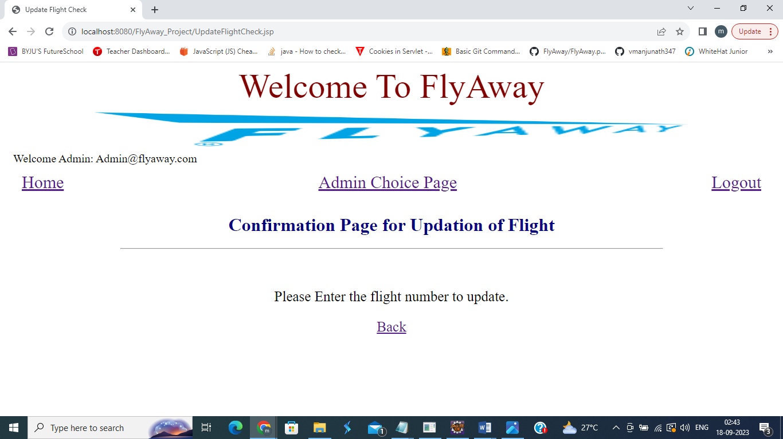

* + 1. **Flight Number Entered that does not exist in DB, will display an error**

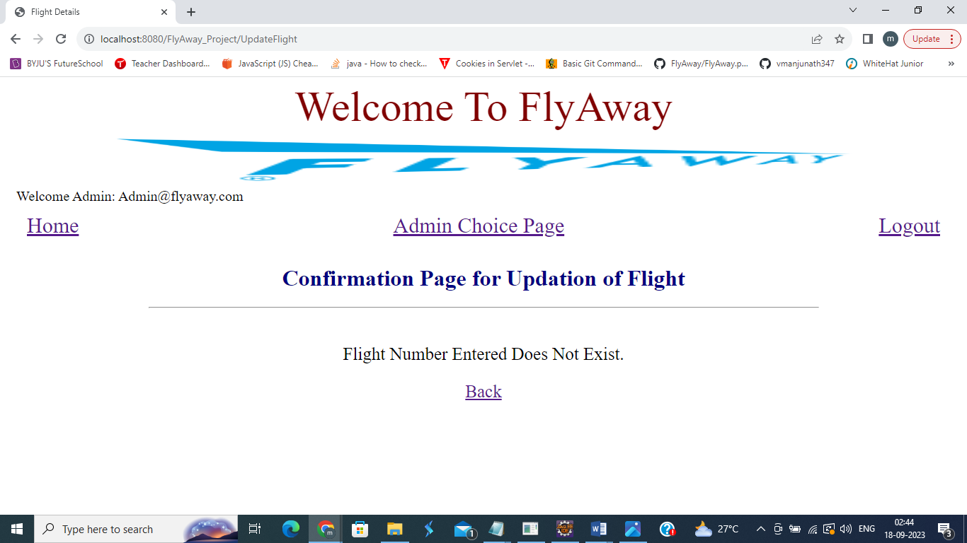

* + 1. **Correct Flight Number Entered that exists in DB**

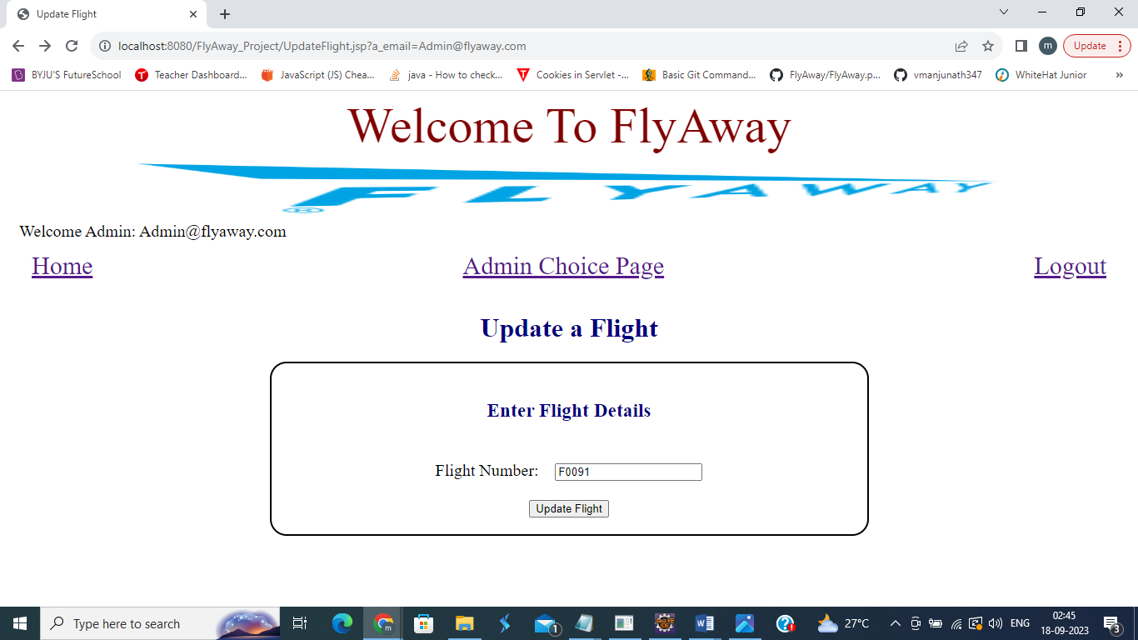

**Flight Details Fetched from DB**

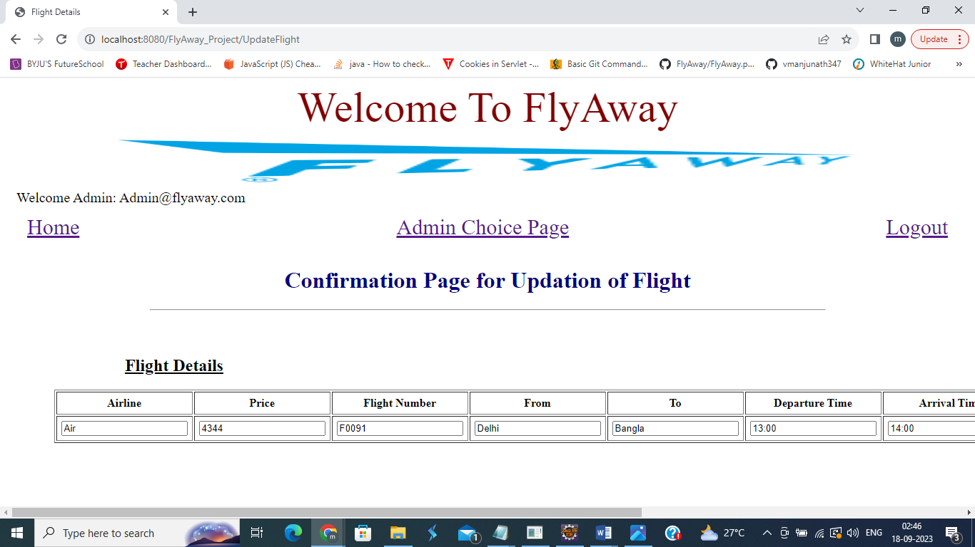

**Edit Button Clicked to Make Changes**

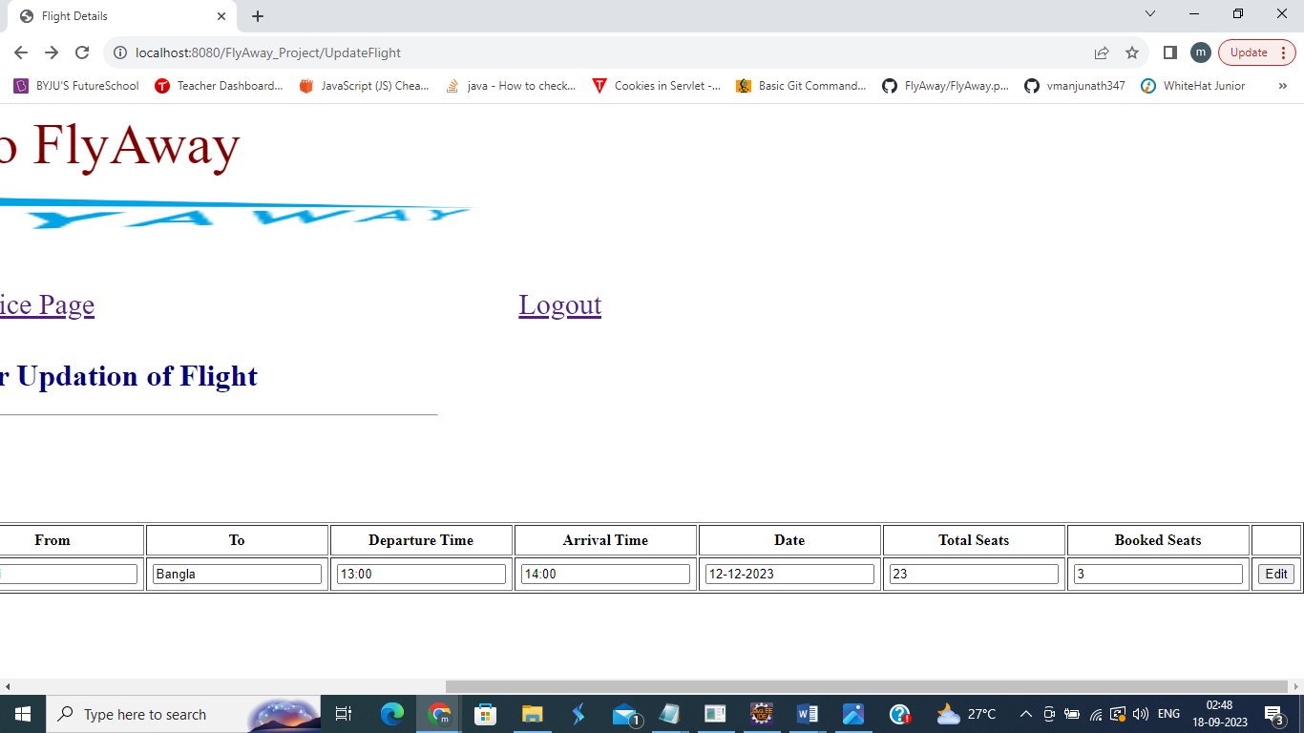

**Confirmation Page to commit changes made**

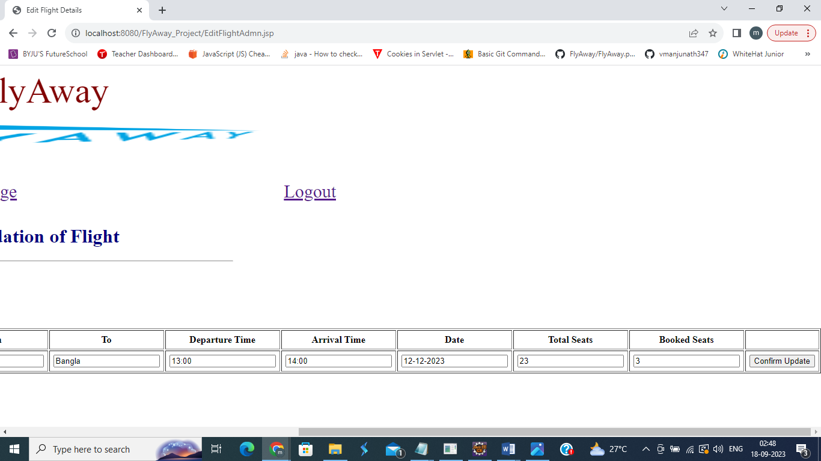

**Flight Updated**

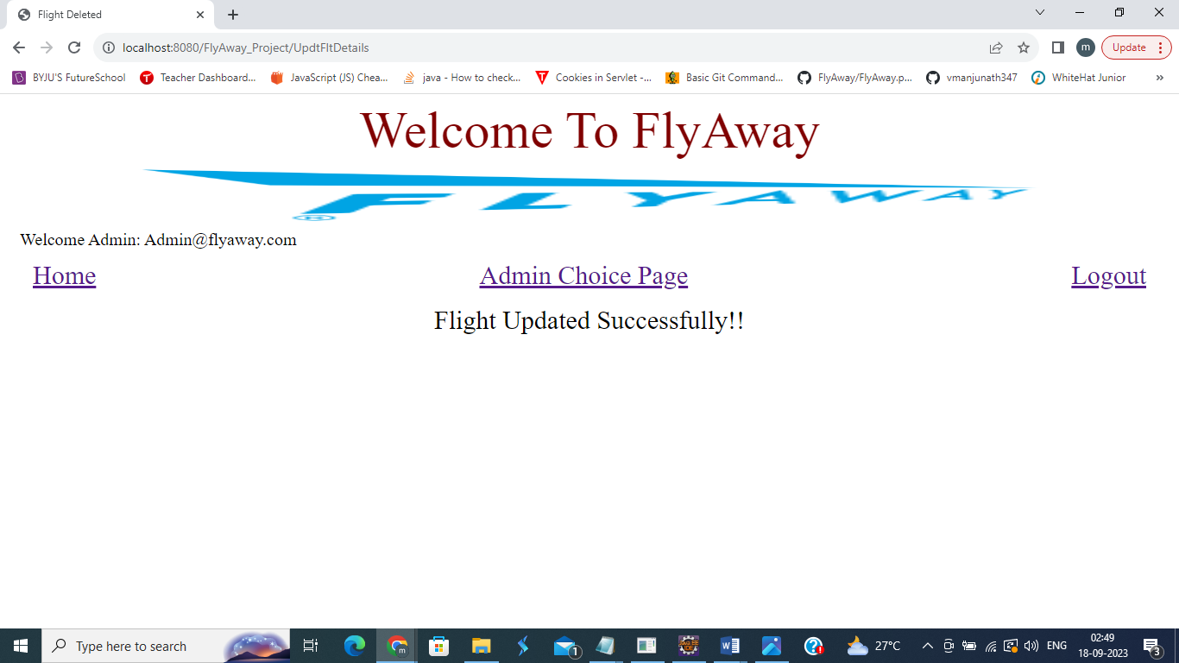

**Tables**

